Assignment 1

* IAM USER CASE: Creation of IAM account to have Full access to S3 Service.
* Setting up Custom Sign-in URL || MFA

Steps to Create IAM USER:

1. Create Policy for S3 for that in IAM Serveice Click on Policy.
2. Click on Cteate Policy and give permission to S3 and Resources Click on – All then Next.
3. policy Name – S3ONLY
4. Click on Create Policy then select Policy Amazon S3 Full Access.
5. Click on Create Policy
6. Click on Create User. And Give name - Pavan
7. Then Select Policy which we already created S3ONLY click on Next - Create user.
8. And download User Crediantials.

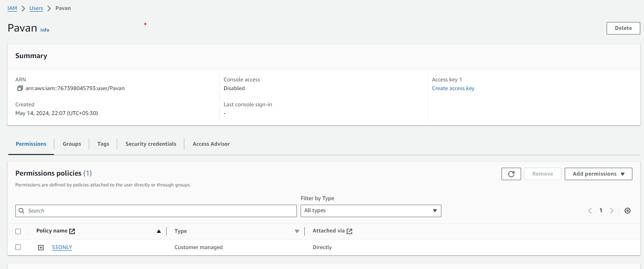

Setting up Custom Sign-in URL || MFA:

1. Open User pavan – Click on Security Credential – Assign MFA Device.
2. Give Device name – Select Authenticator App
3. Scan QR code from Mobile.
4. Open Google authenticator
5. Type MFA1 code and MFA2 code.
6. Add MFA

